Lab 20

1. Calculate the total revenue generated by two product categories in a store

Input:

category1_revenue = np.array([500, 600, 700, 550])

category2_revenue = np.array([450, 700, 800, 600])

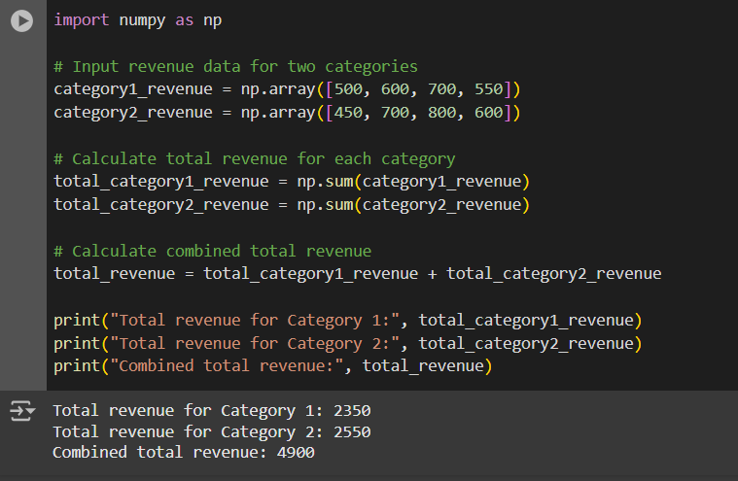

2. Calculate the profit made by a company

Input: revenue = np.array([10000, 12000, 11000, 10500])

expenses = np.array([4000, 5000, 4500, 4800])

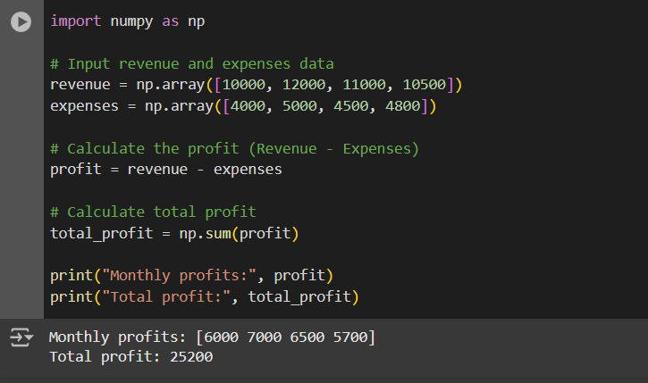

3. Determine which products in a store are out of stock (quantity is 0).

Input: inventory = np.array([10, 0, 5, 0, 20, 0])

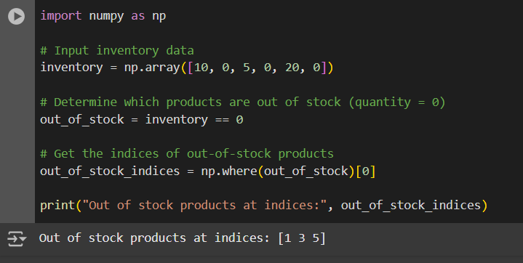

4. Calculate the total cost of items in a shopping cart, considering the quantity and price per item.

Input: quantity = np.array([2, 3, 4, 1]) price_per_item = np.array([10.0, 5.0, 8.0, 12.0])

